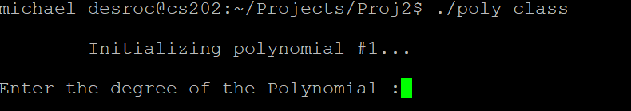

Program asks for Degree of Polynomial

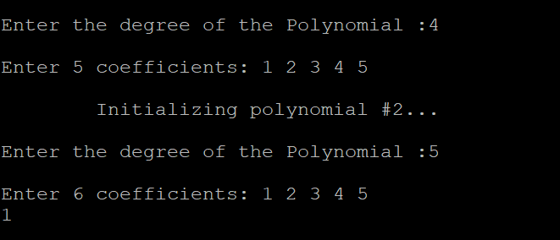

After the degree is entered, it asks for 5 coefficients. Then prompts again for Polynomial #2

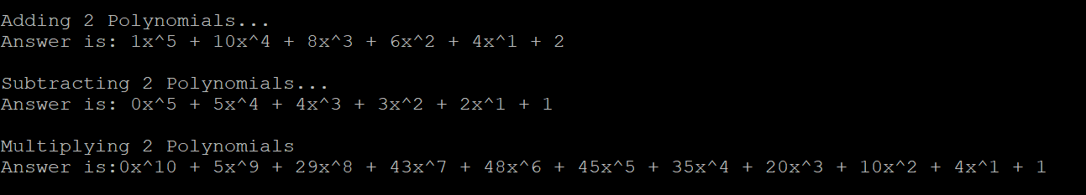

After Inputs are made, It displays the polynomials



Then it shows if the Polynomials are equal

